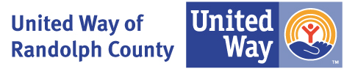

Letter of Intent (LOI) Form
Community Impact Grant Funding Application
Using the format below, print and sign on your agency letterhead. Once completed please email to: jvalentine@uwrandolph.org

Date:
Agency Name:
Contact Person:
Position/Title:
Address:
Phone Number:
Email Address:

- Mission Statement:
[Provide a brief overview of your organization’s mission and core objectives.]
- Key Programs and Services:
[List the primary programs or services your agency provides, focusing on those relevant to this application.]
- Target Population Served:
[Describe the primary population your organization serves, including demographics and geographic reach.]
- Program/Project Title:
[Provide the name of the program or project for which you are seeking funding.]
- Brief Description:
[Describe the program/project in a few sentences, outlining its purpose and objectives.]
- Alignment with United Way Priorities:
[Describe how your program aligns with United Way’s focus areas, such as health, education, or financial stability.]
- Amount Requested:
[Specify the amount of funding you are seeking.

By signing below, I confirm that the information provided in this Letter of Intent is accurate and complete to the best of my knowledge.

Signature

Name:
Title:

